2 Minute Form
Trip Name: Arkles Bay to Shakespear, Whangaparaoa
Check-in Name and Phone:
Date: Branch:
Leaders
Cell Phone Number
VHF Call Sign &/or Vessel Name
Vehicle make, model, registration, colour
General Plan
Note: If plan changes, you must notify your Check-in person.
Latest Time Off the Water |  |  |  |  | TMP/ AMP used²⁰
Tide/ Forecast Lake Level | Low |  |  | High | Other
Communications Carried²¹
Communications | We will be communicating as a group on VHF Channel _____
Equipment Carried
Trip Report
(Use other side if more space required)

Activity | Club trip | Centre | Auckland | Location |  |  | Whangaparaoa Peninsula |  | Difficulty¹ |  |  | Beginners/  strong beginners
Activity Description | Meet at Arkles Bay. Paddle along the coast to Shakespear. This distance is suitable for strong beginners. For a shorter trip stop at Gulf Harbour. This is a suitable destination for new paddlers. Return. |  |  |  | Leader qualification req.² |  | Trip leader
Get in Location | Arkles Bay |  |  |  | Chart/ Map no.⁴ |  | 532 |  | Distance |  |  | 8/16km total
Get out Location | Arkles Bay |  |  |  | Coastguard Channel |  | 60 & 64 |  | Nowcasting |  |  | 19
Emergency get out ⁵ | Any beach along the way, also Gulf Harbour Marina. |  |  |  | Emergency / Coastguard Station |  | Auckland |  | Phone |  |  | *500  09 303 4303
 |  |  |  |  | Drinking Water⁶ | No |  | Toilets⁷ |  |  | Arkles Bay, Gulf Harbour, Shakespear
Emergency Response | Refer Emergency Response Booklet |  |  |  |  |  |  | Parking⁸ |  |  | Arkles Bay, Gulf Harbour, Shakespear
Specific Equipment Required⁹ | None |  |  |  | Working Communications equipment in this area¹⁰ | Cell phone  Sat phone |  |  |  | Mountain Radio |  |  | PLB  VHF
Other resources  and notes¹¹ | Total return distance is approximately 8km to Gulf Harbour, or 16km to Shakespear. This area is sheltered from northerly winds. Just before you reach Gulf Harbour there is a stream which is nice to explore if you have time.  Shakespear is now a pest free bird sanctuary; ensure that your kayak and gear is free of pests including rainbow skinks, Argentine ants, seeds, rodents. |  |  |  | Weather Parameters¹² | Beginner: no significant surf or swell, wind under 15 knots.  Intermediate: surf or ocean swells less than 1.5 metres or wind under 25 knots.  Advanced: any condition that’s suitable for the trip’s aims.
Previous incidents¹³

Safety Management¹⁴
Hazard |  | Significant? |  | Management Strategy¹⁵ |  |  |  | Hazard | Significant? | Management Strategy¹⁵
Cold Water |  | Yes |  | Carry spare dry clothes and shelter |  |  |  | Deep Water | Yes | Correctly fit PFDs
Medical Conditions |  | Yes |  | - Leader has first aid qualification  - Ask customers about medical conditions |  |  |  | Bad Weather | Yes | Understand weather forecasts.  Have back up plans or pull out if necessary
Capsizing |  | Yes |  | - Correctly fit PFDs  - Skills at performing rescues. |  |  |  | Heat / Sun | Yes | - Protective Clothing (worn)  - Sun Screen  - Plenty of drinks  - Sunglasses
Panic |  | Yes |  | Ensure conditions match level  of skills |  |  |  | Obstacles | Ye s | Awareness of reefs, navigational hazards, nets
Entrance to Gulf Harbour |  | Yes – M |  | The entrance to Gulf Harbour is very busy. When crossing, stay together as a group, look out for approaching vessels, cross briskly. |  |  |  | Other Vessels | Yes | - Understand the “rules of the sea”  - “Be seen” – Have two of the following; flag, brightly coloured kayak, brightly coloured Pfd or hat. At night: an all round white light & a powerful torch.
Written up by: | Larraine Williams |  | Approved By: |  | Russell Williams | Signed: | RW |  | Date: | 1 Nov 2017 | Review in: | 12 months from date of approval

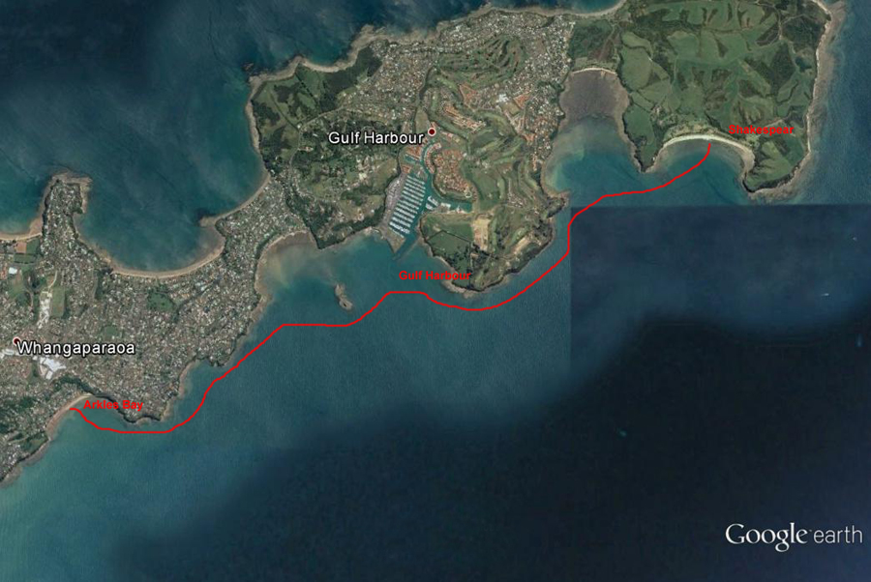
Additional Information Sheet (Optional)
Introduction (A general introduction)
Description (A description of the tour – as if you were selling the idea to someone)
Local Attractions |  | Transport/ Local Operators
 | Contact details |  | Contact details
Local Eateries
 | Contact details
Accommodation/ Campsite Locations |  |  | Facilities
Name |  |  | Cabins |  | Fuel
Phone |  |  | Showers |  | Power
E-mail |  |  | Toilets |  | Water Access
Website |  |  | Laundry |  | Pool
Physical Address |  |  | Water |  | Fires Allowed
Other |  |  | Supplies
Other information

Activity Equipment Check list
Equipment List
- Helmet (rivers & surf) Group Gear
❑ Beanie / hat  Split paddles
❑ Thermals  Repair kit
❑ Paddle Jacket  Fire lighting
❑ PFD  Cooker/thermos
❑ Spray deck  Spare thermals
❑ Booties  Tow system
❑ Water & food  1st Aid Kit
❑ Kayak & paddle  Flares
Group - Oceans & Lakes  Compass
❑ Pumps & Paddle Floats  Charts / Maps
Group - River  GPS (optional)
❑ Throw ropes  Knife (cut rope)
❑ Pin kit & saw  Emergency Shelter

In case of emergency: Dial 111, Mayday :VHF Channel 16

Kayaking Check list

❑ Trip plan
❑ Latest weather forecast
❑ Conditions match skills?
❑ Hyperthermia (hot) &
Hypothermia (cold)
❑ On & off water safety
❑ Environmental concerns
❑ Emergency Procedures include emergency get out.
❑ Working communication devices
e.g. VHF radio, mobile phones, PLB
❑ Specific safety issues for this trip
❑ Participant list
❑ Any medical conditions
❑ All participants keen to proceed?

❑ Trip Plan/ 2-minute form lodged with Ops. Manager

Appropriate wind conditions to run trips:
Novice - no significant surf or swell, wind under 15knots
Intermediate- surf or ocean swells less than 1.5 metre or wind under 25 knots.
Advanced- any condition that is suitable to the trips aims

At conclusion of trip:
Contact check in person
Group Debrief.

Check in Person Ph:
__________________ Mobile
__________________ Work
__________________ Home

Activity Document Cover Sheet

Activity:
Date of Activity:

Activity reports. Is all relevant information present:
– Approved Trip Management Plan (TMP)/ 2 minute form
– Club Trip Participant Sheet
– Weather forecast
– Activity Check List
– Trip report (May be on the 2 minute form)
– Accident / incident reports
Leaders Signature:
Date:

